**Endeavor GCSI Procedure Room Recording System Instructions for Use**

**Introduction:**

This document provides a detailed overview of how different user groups should utilize the Endeavor GCSI Procedure Room Recording System. These instructions are divided into sections for different user groups:

* Section 1: Administrators (GCSI technicians) - initial one-time setup (~10 min)
* Section 2: Administrators (GCSI technicians) - before student recording setup (~2 min)
* Section 3: Administrators (GCSI technicians) - after student recording (~2 min)
* Section 4: Administrators (GCSI technicians) - troubleshooting tips
* Section 5: Students
* Section 6: Facilitators

**Features:**

The Recording System has the following features:

* Requires minimal input from students to record and save videos.
* Allows students to modify camera setup for different procedures.
* Saves video recordings as .mp4 for simple playback on most video players.
* Integrated dragging/resizing of multiple camera angle streams.
* Automatically names video files using students’ information for easy sorting by administrators.
* Simulates kiosk mode to prevent PII access between students.

**Materials:**

To use the Recording System, you will need the following:

* Computer with access to the Internet
* Multiple camera sources (webcams, iPads, etc.)
* Computer with access to the GCSI shared drive
* Encrypted USB drive

**Section 1: Administrators (GCSI technicians) – initial one-time setup (~10 min)**

**Introduction:**

This section outlines the **one-time**, initial setup process required to configure the recording system on a PC. These steps are only necessary the first time the system is used, or if the PC is factory reset or replaced. After this initial setup has been completed, please refer to Section 2.

**Step 1: Open and create password for Windows administrator account**

Open Windows administrator account (see Figure 1).

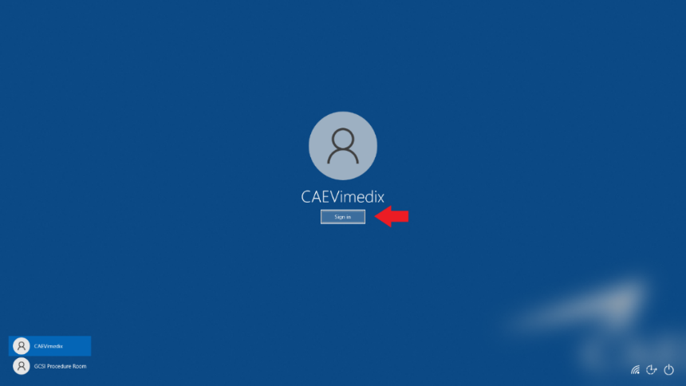

*Figure 1*: Windows administrator account sign-in

Create a new administrator password (see Figures 2-4). Write down/store password in a secure location.

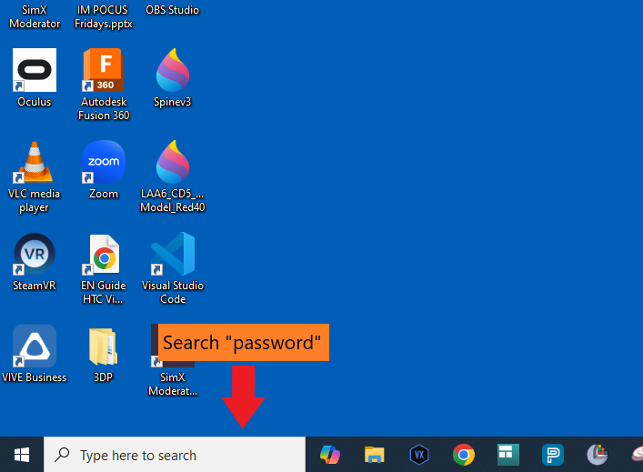

*Figure 2*: Search “password” in desktop search bar

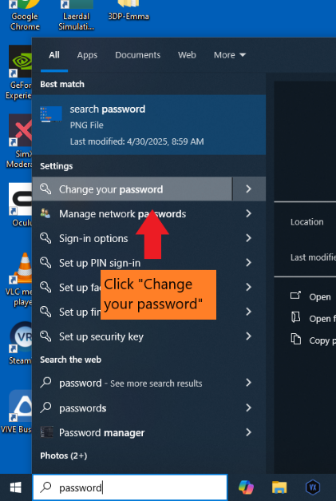

*Figure 3*: Select “Change your password”

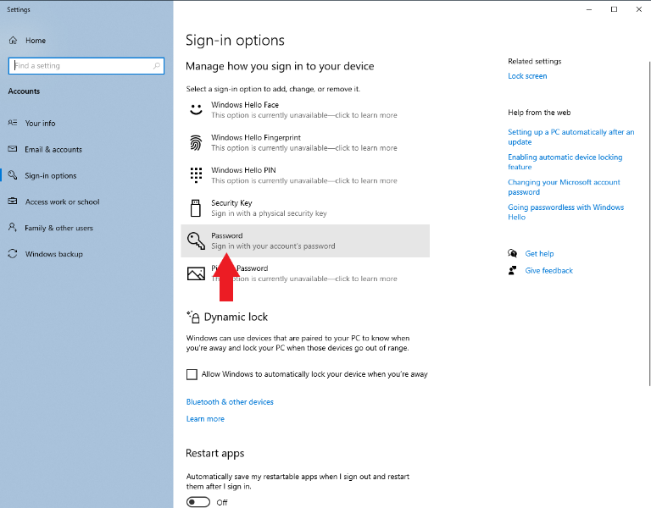

*Figure 4*: Select “Password” to add a new password

**Step 2: Create password for Windows Guest account**

Create a guest/standard account for student use (with limited access to Windows controls):

* Go to computer settings and click on “Accounts.”
* Navigate to “Family and Other Users.”
* Click “Add Someone else to this PC” -> click “The person I want to add doesn’t have an email address” -> click “add a user without a Microsoft Account.”
* Enter your desired name for the account (e.g., GCSI Procedure Room) and create a password for the account. Write down/store password in a secure location. Click “Next.”

Open the guest/standard account you just created via the Start menu (see Figures 5 and 6):

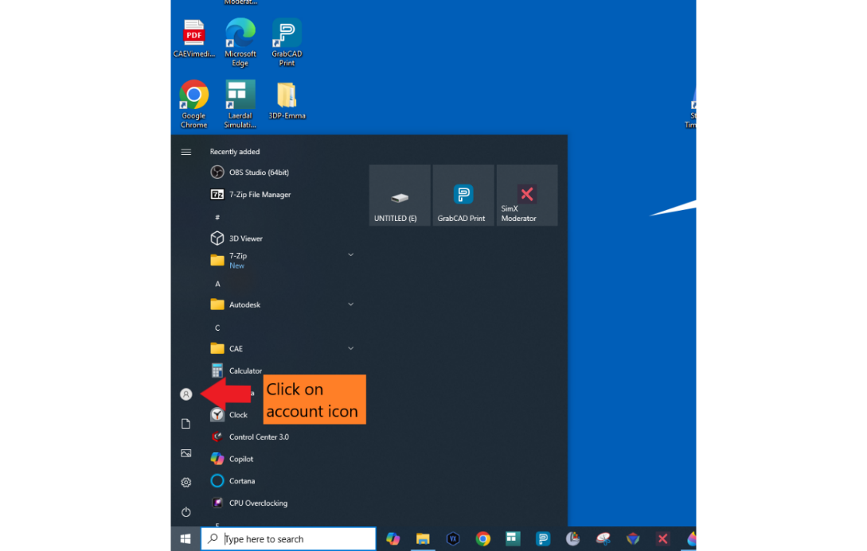

*Figure 5*: Click on account icon

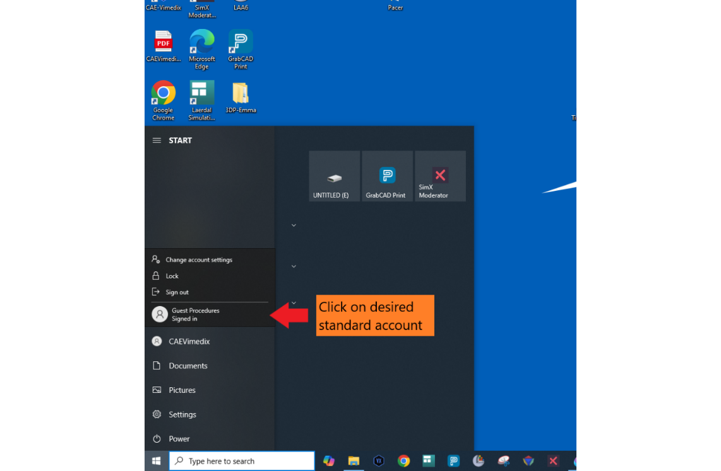

*Figure 6*: Select guest/standard account

**Step 3: Download Procedure Room Recording System files**

Now that you are in the guest account, open a browser window (e.g., Google Chrome, Microsoft Edge, etc.) and navigate to <https://github.com/jchen6589/Endeavor-GCSI-Procedure-Room-Recording-System>. Click on the latest release under “Releases” (see Figure 7).

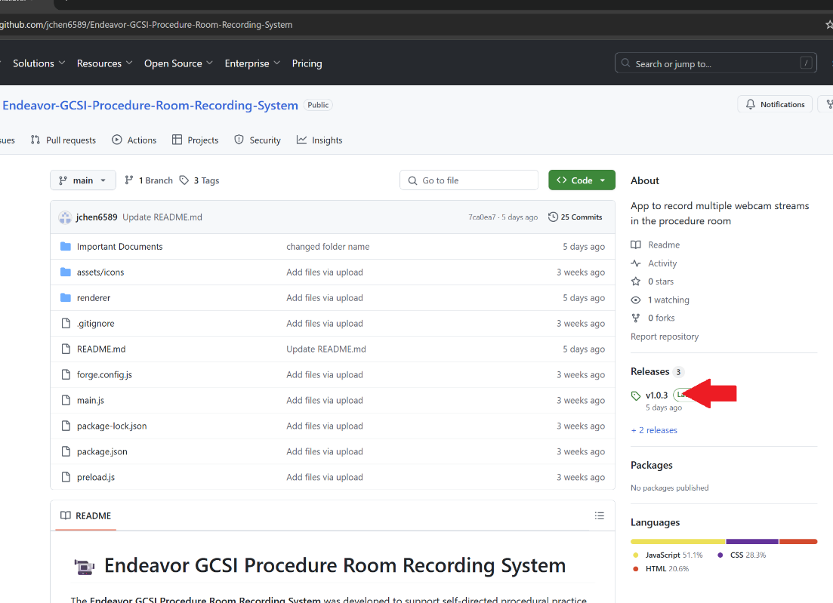

*Figure 7*: Open latest release

Download the lockdown.exe and Setup.exe file to your computer (see Figure 8).

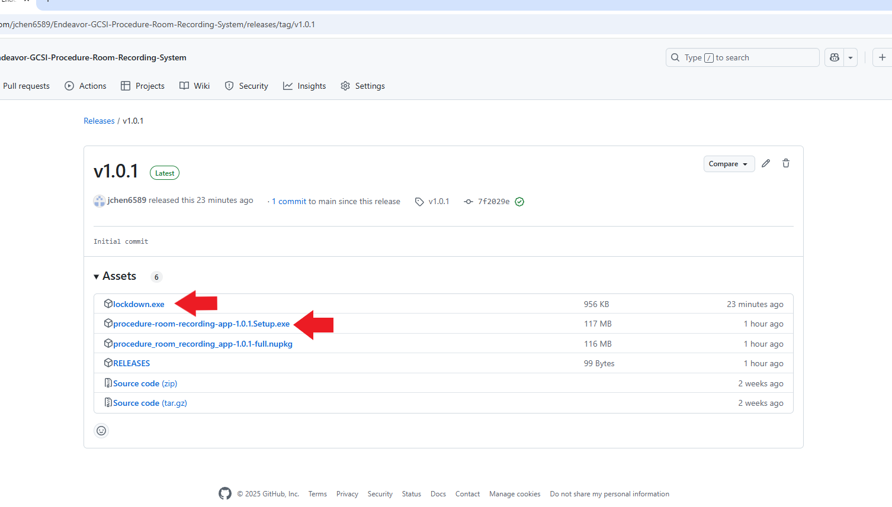

*Figure 8*: Download lockdown.exe and Setup.exe files

Open the Downloads folder in your computer’s File Explorer. Double-click the Setup.exe file to install the recording app (see Figure 9). If Windows sends you a warning, override it by clicking “More info” and then “Run anyway” (see Figures 10 and 11).

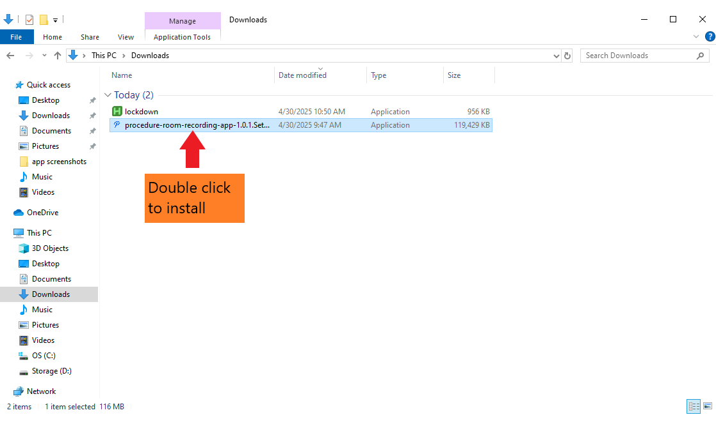

*Figure 9*: Install procedure-room-recording-app

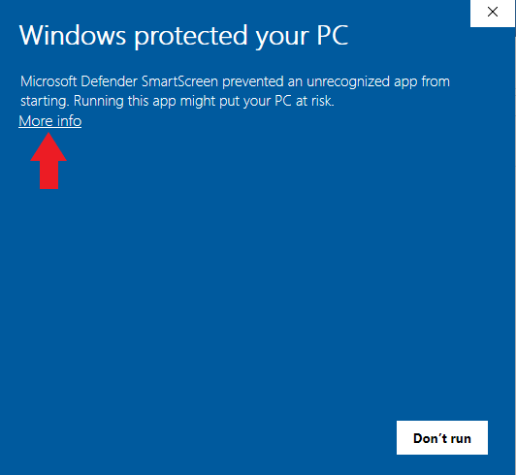

*Figure 10*: Click “More info”

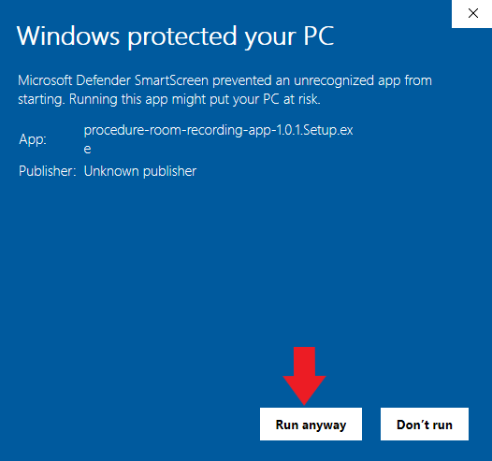

*Figure 11*: Override Windows Defender

Press Win+D on your keyboard to minimize the app and return to the desktop.

**Step 4: Add procedure-room-recording-app.exe and lockdown.exe to startup folder**

Use the following steps to add the apps you just downloaded to the guest/standard account’s startup folder so they open automatically upon sign-in. Still within the guest account, perform the following:

* Press Win+R on your keyboard -> type “shell:startup” -> click “OK” (see Figure 12)

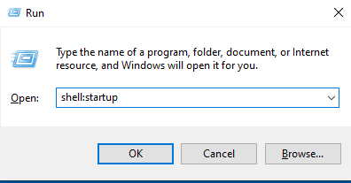

*Figure 12*: Open “shell:startup”

* Create procedure-room-recording-app.exe shortcut:
  + Right-click -> select “New” -> select “Shortcut” (see Figure 13)
  + Click “Browse” -> scroll down and select “procedure-room-recording-app” (see Figure 14) -> click “OK” -> click “Next” -> click “Finish”

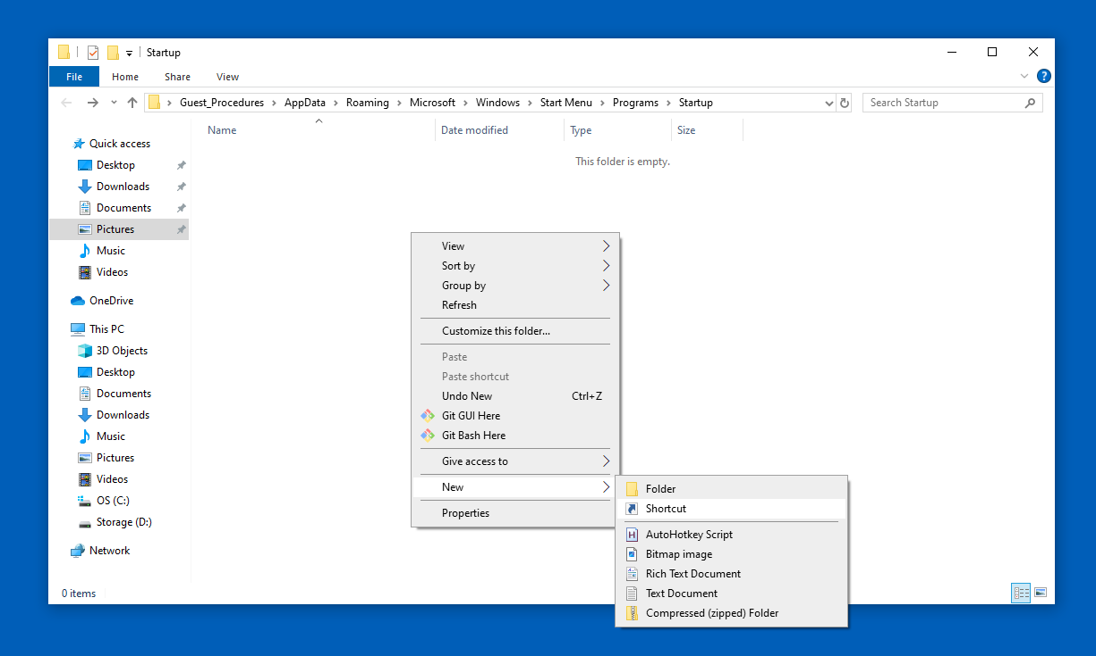

*Figure 13*: Create shortcut for app

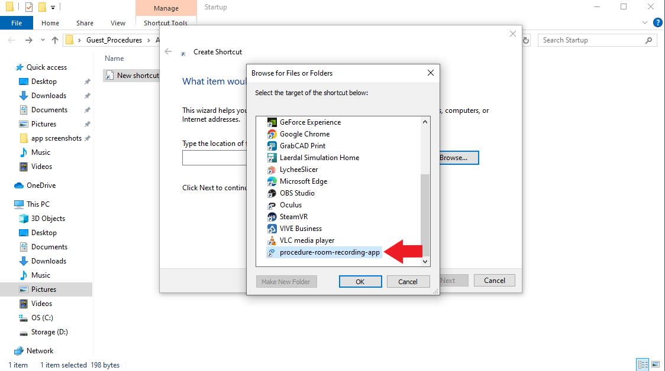

*Figure 14*: Select procedure-room-recording-app.exe location

* Create lockdown.exe shortcut:
  + Right-click -> select “New” -> select “Shortcut” (see above)
  + Click “Browse” -> click “This PC” -> click “Downloads” -> click “lockdown” (see Figure 15) -> click “OK” -> click “Next” -> click “Finish”

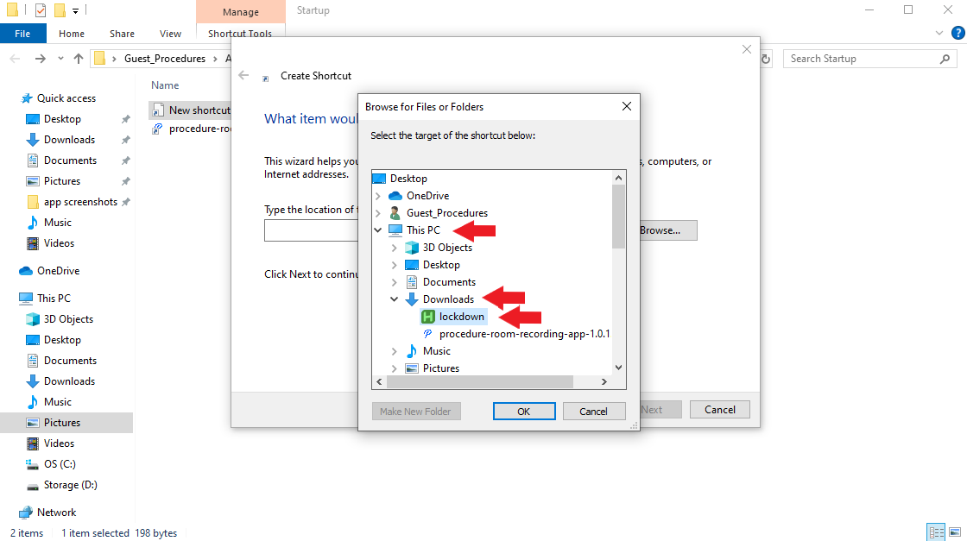

*Figure 15*: Select lockdown.exe location

**Step 5: Set up system-level restrictions for guest account**

The lockdown.exe file disables common keyboard shortcuts for exiting an app, switching apps, and activating other Windows features (the script it originates from is called “lockdown.ahk”, which can be viewed in the GitHub repository). To further prevent users from closing out of the app and potentially viewing others’ recordings (a breach of PII), we want to set up some extra restrictions for the guest account.

Open guest account Settings. Set up the following:

* Disable swipe gestures:
  + Search “Touchpad settings” -> “Three-finger gestures” -> set “Swipes” and “Taps” to “Nothing”
  + Search “Touchpad settings” -> “Four-finger gestures” -> set “Swipes” and “Taps” to “Nothing”
* Set sleep to never:
  + Search “Power & sleep settings” -> set all dropdown menus to “Never”
* Autohide taskbar:
  + Search “Taskbar settings” -> Turn on “Automatically hide the taskbar in desktop mode”
* Turn off shortcuts for Sticky Keys, Toggle Keys, Filter Keys:
  + Search “Ease of Access” -> “Keyboard” -> Uncheck “Allow the shortcut key to start Sticky Keys,” “Allow the shortcut key to start Toggle Keys,” and “Allow the shortcut key to start Filter Keys.”

Return to the administrator account. Set up the following:

* Disable task manager option for Ctrl+Alt+Delete via Group Policy:
  + Press Win+R on your keyboard -> type “gpedit.msc” -> press “Enter”
  + Go to “User Configuration” -> “Administrative Templates” -> “System” -> “Ctrl+Alt+Delete Options”
  + Double-click “Remove Task Manager” -> set to “Enabled” -> click “OK” -> close out of Group Policy Editor

**Restart your computer to ensure all changes are applied.**

**This concludes Section 1! Please refer to Section 2 to set up cameras and the student interface.**

**Section 2: Administrators (GCSI technicians) - before student recording setup (~2 min)**

**Introduction:**

Once Section 1 has been completed on your PC (you only need to do it once!), use the following instructions to finish setting up the recording system. You should also refer to these instructions in the following situations:

* Each time after you transfer student recordings to a network computer (see Section 3).
* PC is shut down and applications must be reopened.

**Step 1: Sign in to Windows Guest account**

If the computer is not already in the guest account, please sign in. If the computer is already signed into the guest account but the app is not open, please sign out and sign back in.

Once signed in, the app will open automatically. Wait until the app landing page loads (see Figure 16). This may take a few seconds. Leave the app on the landing page for student use.

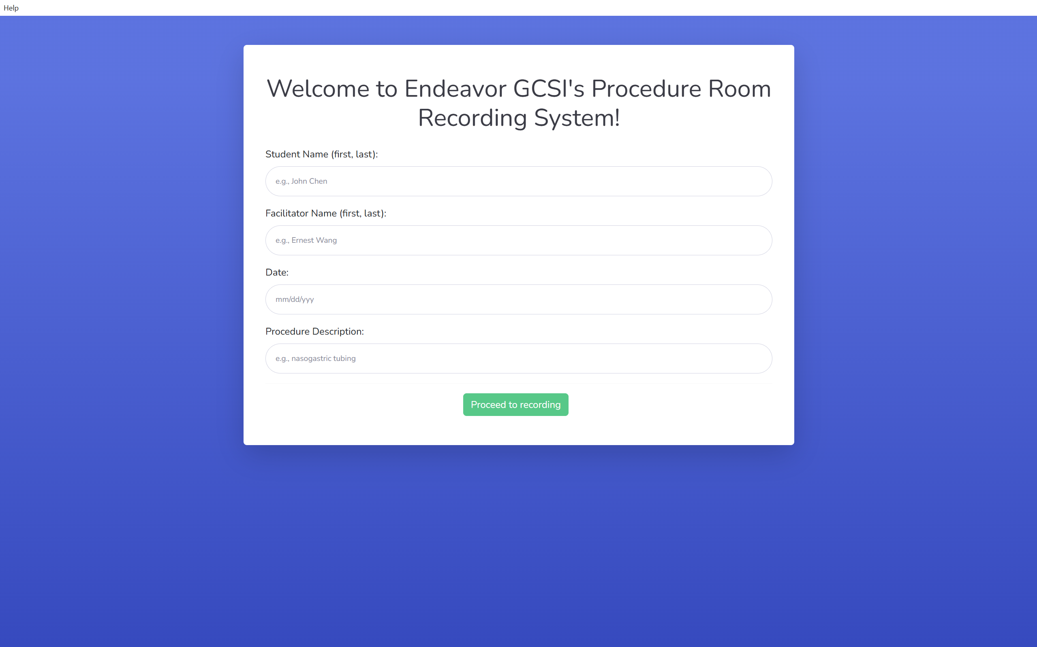

*Figure 16*: App landing page

*Note: If a popup similar to the one below opens upon signing into the guest/standard account (see Figure 17), uncheck “Always ask before opening this file” and click “Run.”

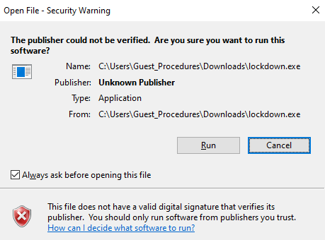

*Figure 17*: lockdown.exe popup

**Step 2: Plug webcams into computer**

Plug webcams (and ultrasound + capture card, if needed) into the computer. Refer to the Camera Setups sheets to determine the recommended camera setup for each procedure type, then set up webcams around the procedure area as desired (see Figure 18).

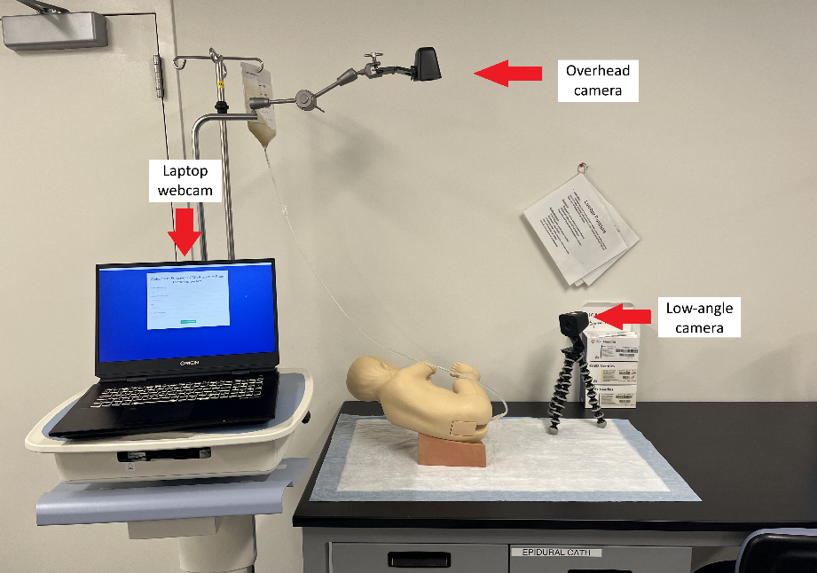

*Figure 18*: Example of camera setup

Leave the Student Instructions sheet and Camera Setups sheets out for student use during recordings. The system is now ready for students to record!

Student recordings will be automatically saved to a folder called C:\Procedure Room Recordings. After students finish recording, please refer to **Section 3** for transferring files for facilitator viewing.

**Section 3: Administrators (GCSI technicians) - after student recording (~2 min)**

**Introduction:**

This section provides instructions for administrators (GCSI technicians) on retrieving student recordings to send to facilitators. This process should be completed after each day of recordings (or more frequently if needed) to ensure feedback is provided in a timely manner.

**Step 1: Open Windows administrator account**

From the guest/standard account, press Ctrl+Alt+Delete on your keyboard to escape the app. Click “Switch user” and sign into the administrator account.

**Step 2: Share student recordings with facilitators**

Now that you are in the administrator account, open File Explorer and locate the folder C:\Procedure Room Recordings in your C-drive (this folder was created automatically upon running the app for the first time). Move all files in this folder to an encrypted USB drive (see Figure 19). **Delete all files from “C:\Procedure Room Recordings**” **once finished**.

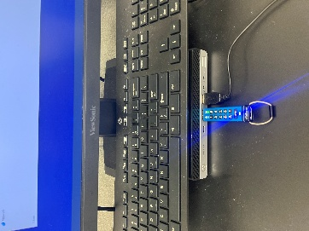 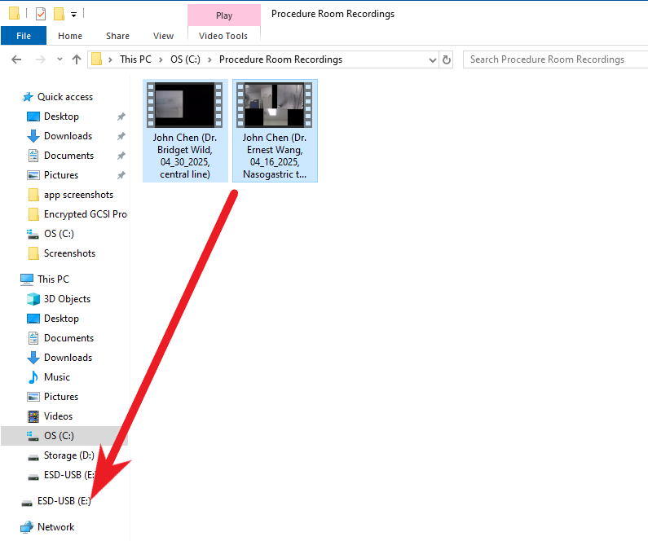

*Figure* *19*: Move student recordings into encrypted USB

Plug the encrypted USB into a computer with access to GCSI’s shared drive (e.g., the computer in your office). Upload files into a folder that facilitators have access to and notify them that the recordings are available.

**Step 3: Charge wireless webcams**

Charge the wireless webcams between student recordings to ensure battery life is sufficient for the next recording session.

**Section 4: Administrators (GCSI technicians) - troubleshooting tips**

**Introduction:**

This section provides troubleshooting tips for administrators (GCSI technicians) on problems during recording system setup.

**Troubleshooting tips:**

* Sound is recorded through the default laptop microphone. If there is no audio in student recordings, it may be because the student is standing too far from the laptop. Otherwise, check system settings to ensure that the laptop microphone is enabled.
* As recordings get longer (>30 minutes), the app may experience some lag. Encourage students to be patient.
* If a webcam is not being detected while in the recording page, use the back button to return to the landing page. Unplug and plug the webcam back in, then click “Proceed to recording” to check if webcams are detected.
* If a webcam stream appears black, check to see that nothing is covering the lens. For wireless webcams, ensure that the green WiFi light is on. If not, press the power button until the green WiFi light turns on.
* Sometimes, the headband POV webcam can be blurry due to problems with autofocus. You can disable autofocus using different software for different cameras:
  + Logitech C525 (can only be modified on Windows 10 or earlier): Download the Windows 10 version of the C525 Camera Settings software (<https://support.logi.com/hc/en-us/articles/360024689894--Downloads-HD-Webcam-C525>) and toggle autofocus off.
  + Logitech C920: Download Logitech G HUB and toggle autofocus off.
  + You may also use a third-party app, such as <https://github.com/Itaybre/CameraController>.

**Section 5: Students**

**Introduction:**

This section provides instructions for students to use the recording system.

**Student instructions:**

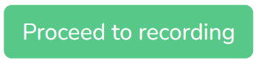

1. Enter your information and click

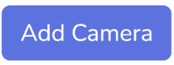

1. Select camera streams to add using the dropdown menu, then click
2. Use the Camera Setups sheet to find recommended orientations for dragging and resizing your camera streams based on the procedure you are completing. Drag and resize camera streams within the recording window as needed.



1. Click
2. Replay, delete, and redo your recording as needed.



1. Click when you have finished recording. Your recording will be named according to the information you provided earlier and will be made accessible to your facilitator. You're all set!

*Note: The workspace and camera angles should be set up for you already. You can confirm that the camera setup is correct using the Camera Setups sheet.

**Troubleshooting tips:**

* Sound is recorded through the default laptop microphone. If there is no audio when you replay your recording, it may be because you are standing too far from the laptop. Otherwise, have an administrator check system settings to ensure that the laptop microphone is enabled.
* As recordings get longer (>30 minutes), the app may experience some lag. Please be patient!
* If webcams are not being detected while in the recording page, use the back button to return to the landing page. Unplug and plug the webcam back in, then click “Proceed to recording” to check if webcams are detected.
* -If a webcam stream appears black, check to see that nothing is covering the lens. For wireless webcams, ensure that the green WiFi light is on. If not, press the power button.

**Section 6: Facilitators**

**Introduction:**

This section provides instructions for facilitators to use the recording system.

**Facilitator instructions:**

1. Locate .mp4 files in the GCSI shared drive.
2. To view, open in Windows Media Player, VLC, or browser (Chrome, Edge, etc.).